Only for Autonomous
As prepared on: 4/04/2024

Progressive Education Society’s
Modern College of Arts, Science and Commerce (Autonomous)
Shivajinagar, Pune -5
Time Table for First Year PG
SCIENCE FACULTY (M.Sc. Analytical Chemistry)
ESE Examination Mar-Apr 2024
Sem II Backlog

Extra credit
Date | Time | Subject Code | Subject name
09-05-2024 | 2.30 pm to 3.30 pm | 19CpHrtP202 | Human Rights II
10-05-2024 | 2.30 pm to 3.30 pm | 19CpCysP201 | Cyber Security II
Regular credit
11-05-2024 | 2.30 pm to 4.30 pm | 19ScCheP201 | Fundamentals Of Physical Chemistry II
15-05-2024 | 2.30 pm to 4.30 pm | 19ScCheP202 | Co-ordination & Bio-inorganic Chemistry
16-05-2024 | 2.30 pm to 4.30 pm | 19ScCheP203 | Synthetic Organic Chemistry
17-05-2024 | 2.30 pm to 4.30 pm | 19ScCheP204 | Sophisticated Instrumentation & Sensor Based Techniques

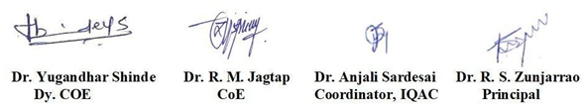

Instructions to Students:
- Please ensure that you will reach the examination Hall 25 minutes before examination time.
- Duly signed Hall ticket and college ID card is compulsory to attend the examinations
- Use of mobile phone and smart watch is strictly prohibited.
- If any misconduct by any student will be confirmed by Examination Squad during examination then appropriate ‘Disciplinary Action’ will be admissible against the student as per SPPU rules.
- For CIE Backlogs, contact the concerned Department.

